FRUIT & NUT RELISH
(HAROSETH)

This recipe is derived from the Jewish dish Haroseth, traditionally served as part of the Passover Meal around Easter. Recipes for Haroseth can vary greatly depending on their origin and ingredients. Have a look at the Tips for uses of this delicious, ancient recipe.

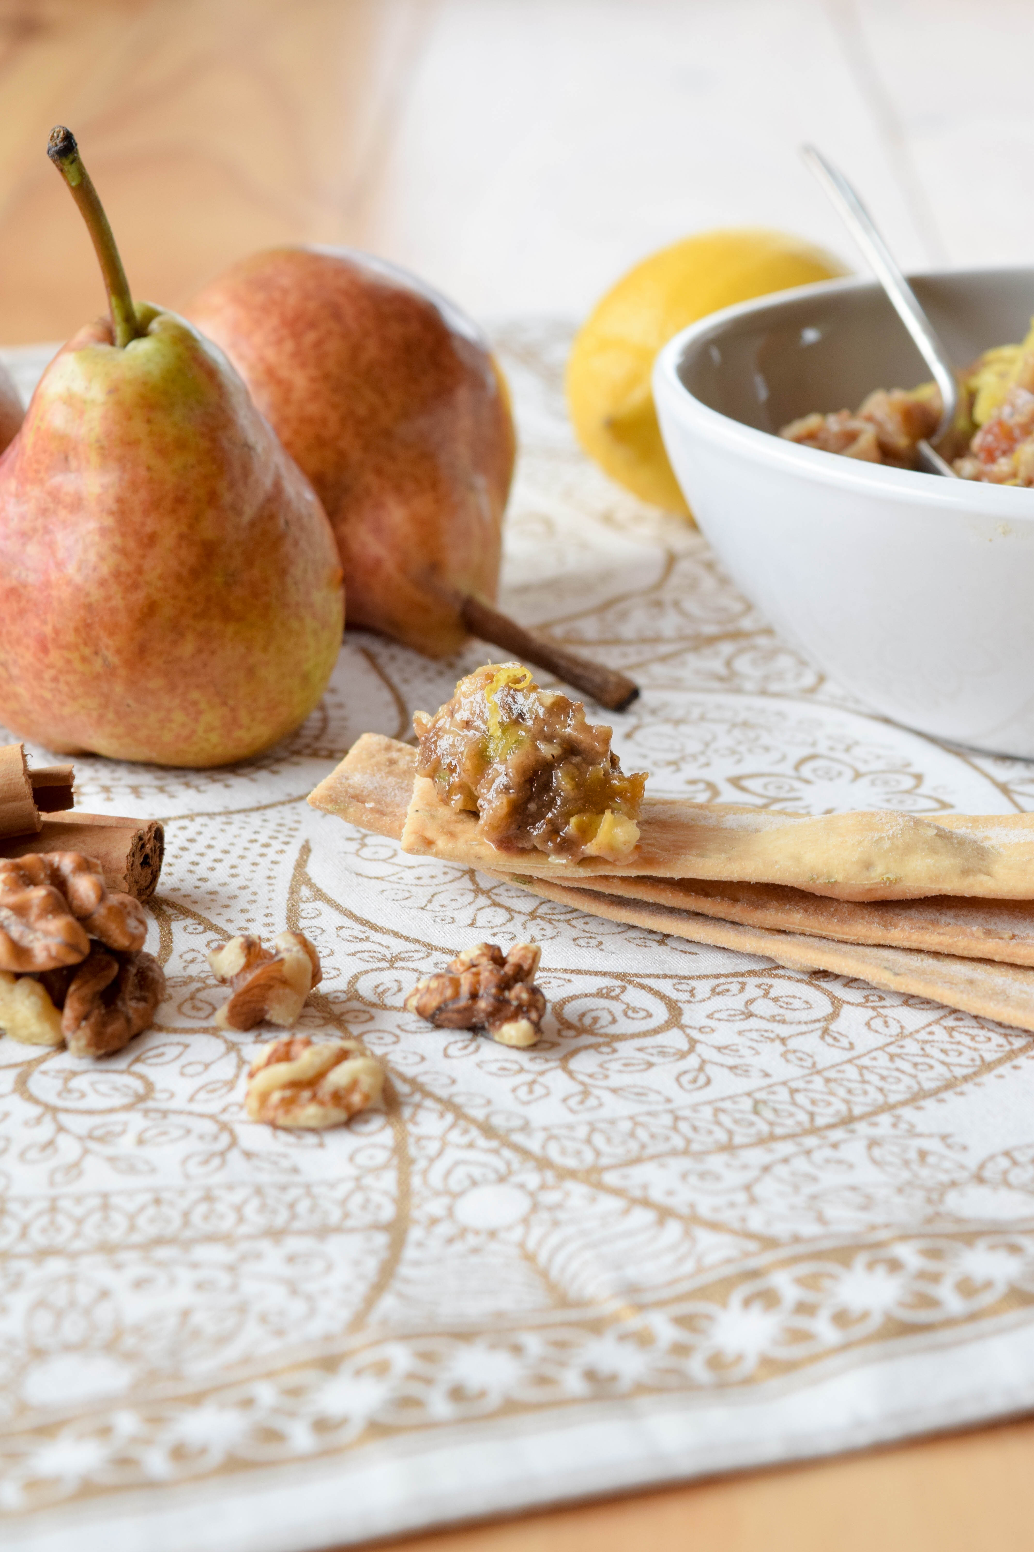

Makes 4 cups
INGREDIENTS
Juice and zest of a lemon
100g walnuts or pecan nuts
170g dried figs, halved
170g pitted Medjool dates
4 just ripe pears, quartered, cored, skin on
1 green apple, quartered, cored, skin on
20g brandy
50g honey
1 tsp ground cinnamon

METHOD
1. Place lemon zest in mixing bowl and chop 10 sec/speed 9. Scrape down side of bowl with spatula and chop 10 sec/speed 9.
2. Add walnuts, figs and dates and chop 10 sec/speed 7. Transfer mixture to a large bowl.
3. Place pears, apple and lemon juice in mixing bowl and chop 3 sec/speed 4. Add to chopped dried fruit and nuts.
4. Place brandy, honey and cinnamon in mixing bowl and heat 2 min 30 sec/100C/speed 2. Pour over chopped fruit and nuts and stir with spatula until combined.
5. Cover bowl and place in the fridge for at least 2 hours to allow the flavours to develop.
See serving suggestions below

Tips
- Serve as a relish to cooked meats such as roast lamb or chicken
- Serve with cheese on a cheese platter
- Serve with yoghurt for a delicious dessert or breakfast
- Use as a tart filling or rolled into balls and coated with desiccated coconut
- Substitute brandy for apple juice
- Will keep in the fridge for up to 5 days

