PUMPKIN & DATE
SCONES

Full of goodness, vitamins and minerals and dietary fibre from the pumpkin and dates, these light and luscious scones are a warming pick-me-up on a cold winter’s day.

Makes 14

INGREDIENTS
150g dates, fresh or dried (seeds removed)
250g plain flour
200g wholemeal flour
2 teaspoons baking powder
½ teaspoon bicarb soda
40g rapadura or brown sugar
¼ teaspoon sea salt
120g chilled butter, cut into small pieces
150g cooled mashed pumpkin
2 teaspoons apple cider vinegar
100g buttermilk, milk kefir or natural yoghurt
100g full cream milk

Tips
- Can be frozen for up to 3 months
- Substitute 100g raisins for dates

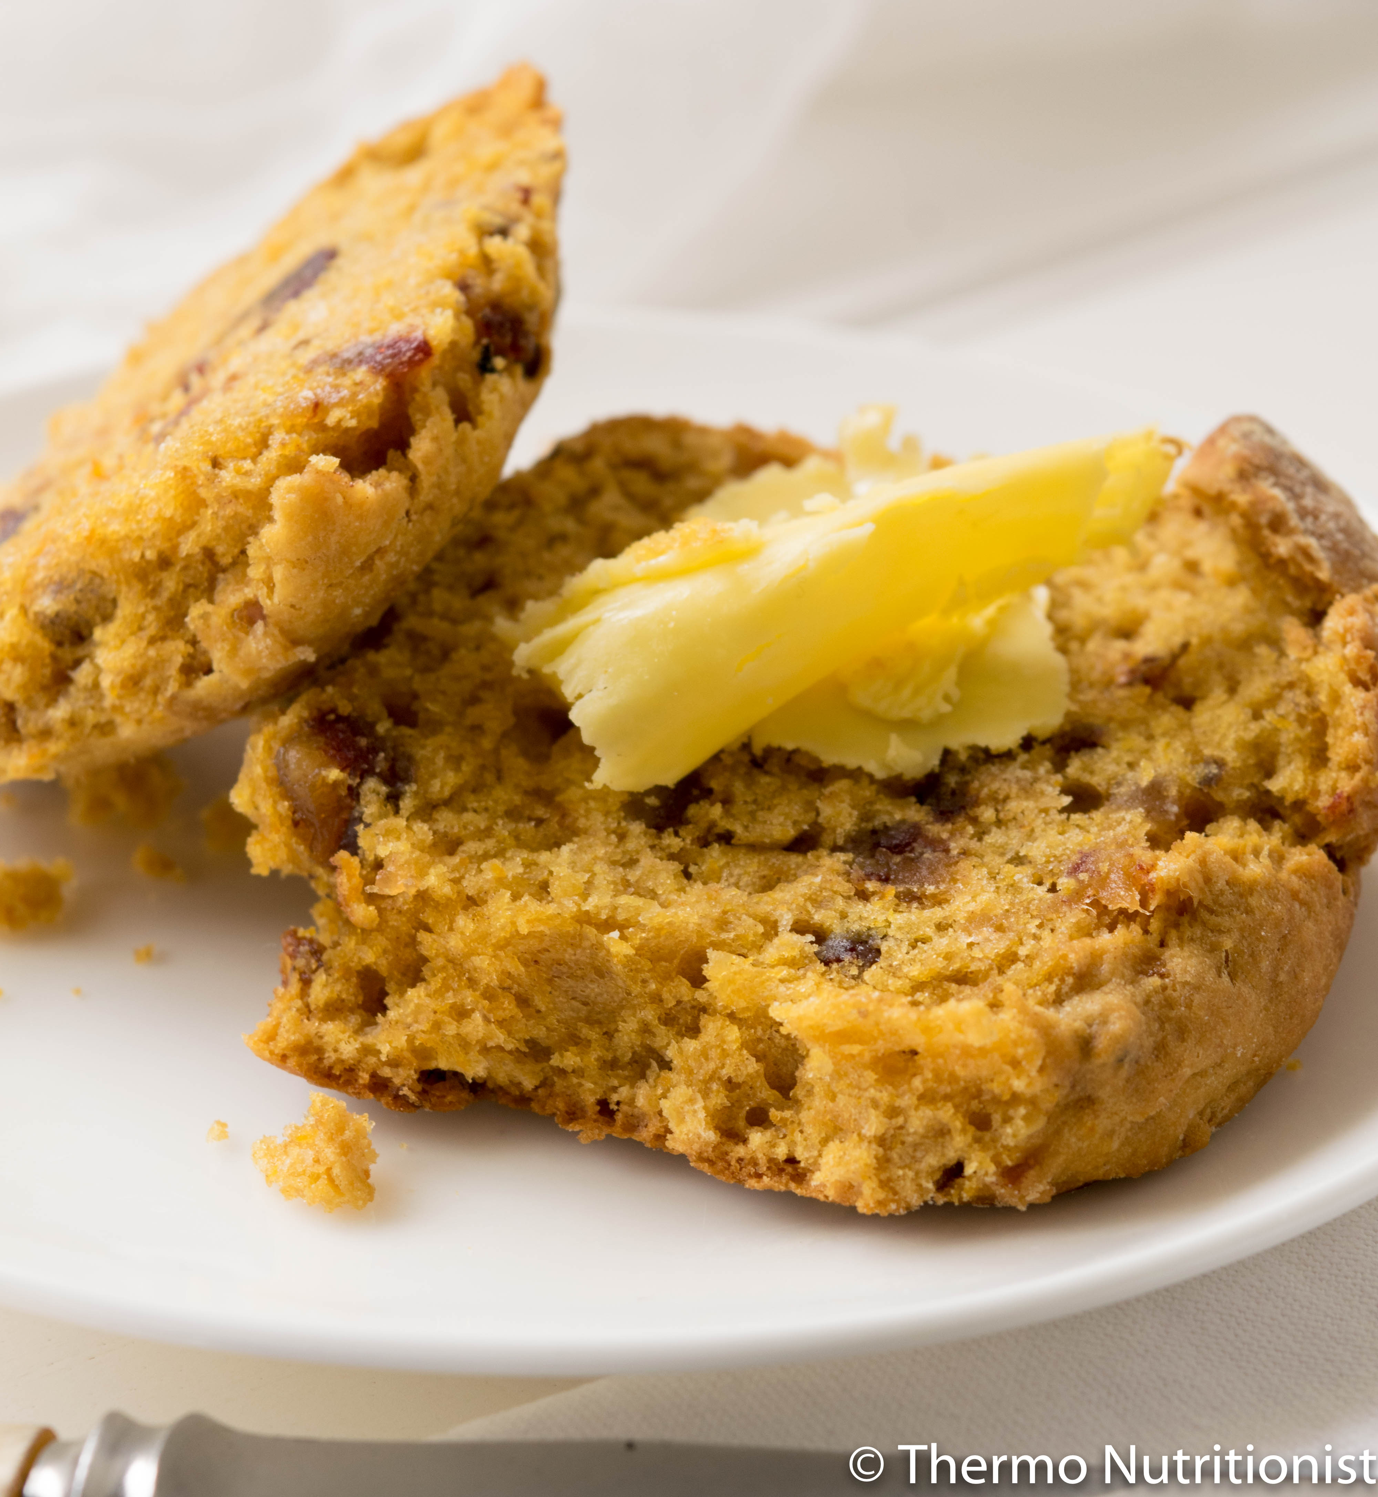

METHOD
- Preheat oven to 180C fan-forced.

- Place dates in mixing bowl and chop
3 sec/speed 6. Transfer into bowl and set aside.

- Place flours, baking powder, bicarb soda, sugar and salt in mixing bowl and mix 10 sec/speed 6.

- Add butter and Turbo 1 sec x 3 until mixture resembles fine breadcrumbs. Scrape down sides of bowl with spatula.

- Add mashed pumpkin, apple cider vinegar, buttermilk, milk and reserved dates and mix 10 sec/speed 5, or until mixture comes together.

- Transfer mixture onto a well-floured surface or Thermomat and bring mixture together to form a round disc approx. 3cm high.

- Cut out 14 scones with a 4cm scone cutter, dipping your cutter in flour as you go. Transfer the scones onto the baking tray, placing so they just touch each other. This will help them rise. Bake for 20 - 25 minutes or until golden. Serve warm with butter, or just as they are.

