VEGAN RASPBERRY & ALMOND CAKE

Makes about 10 serves

INGREDIENTS
100g raw almonds
zest and juice of a lemon
270g spelt flour
1 ½ tsp baking powder
½ tsp bicarb soda
100g castor sugar or 50g stevia
250g almond milk
50g macadamia nut oil, olive oil or melted coconut oil
1 tsp vanilla bean paste
2 tbsp flaked almonds
Handful fresh or frozen raspberries

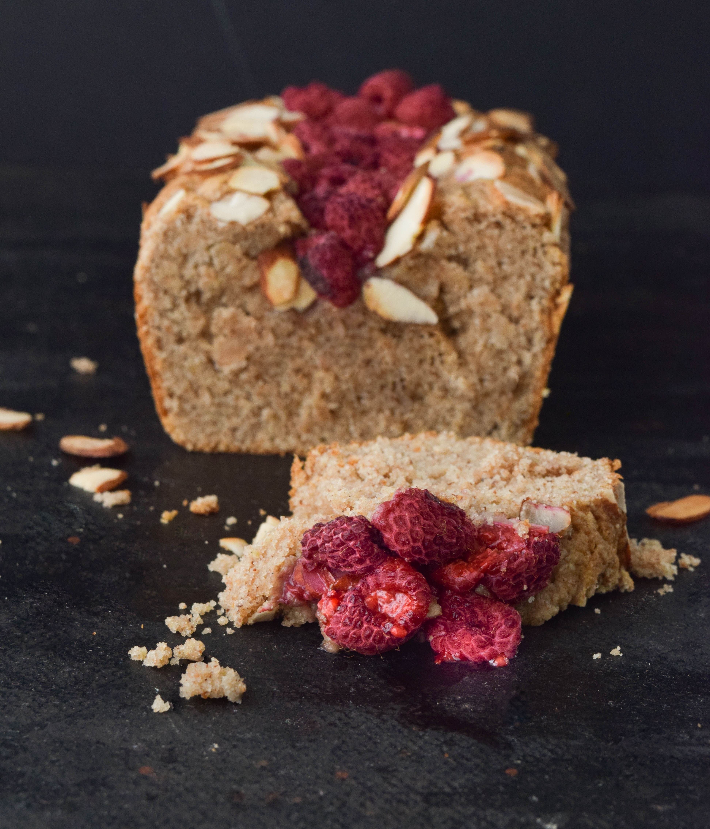

METHOD
- Preheat oven to 170C. Grease and line a small loaf tin.
- Place almonds and zest in mixing bowl and mill
10 sec/speed 10.
- Add remaining ingredients, including lemon juice, and mix until just combined for 6 sec/speed 5 (there may be a few lumps but that’s ok).
- Pour batter into the loaf tin and scatter over flaked almonds and raspberries. Bake at 170C for 30-35mins or until golden. Allow cake to cool in tin and then transfer to a wire rack to cool completely.

Tips
Suitable for freezing
Substitute almond milk for any other milk
Serve cake topped with fresh raspberries and cashew cream or coconut yoghurt

