Date and Walnut Roll
Natural sugars in dried fruit are a great replacement for refined sugars in many recipes. Here, the sugar content has been halved due to the natural sweetness of the dates. Brown sugar has been replaced with unrefined rapadura which is higher in nutrients, especially minerals. The overall result is a healthy, fibre rich snack that is not too sweet.

Makes 2 Rolls

Ingredients

80g unsalted butter, cut into small pieces, plus extra for greasing
250g filtered water at room temperature
1 teaspoon bicarb soda
1 teaspoon vanilla paste
1 teaspoon mixed spice
100g rapadura sugar
150g spelt flour
150g wholemeal spelt flour
½ teaspoon baking powder
1 egg
80g walnuts, roughly chopped
180g dates, roughly chopped

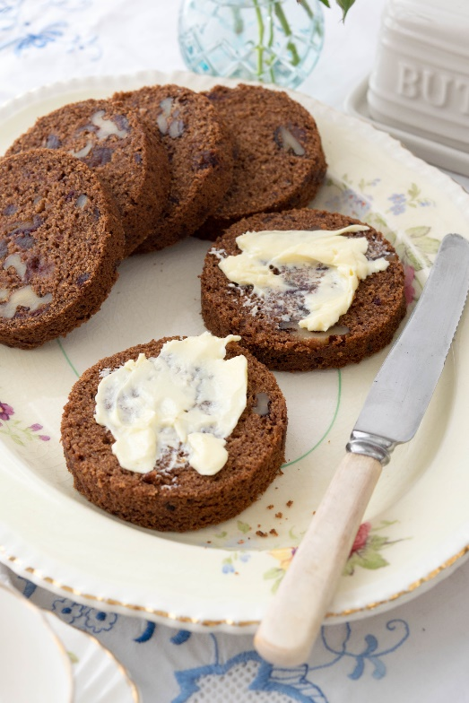

Method

1. Grease two 20cm x 8cm roll tins and set aside.

2. Place water and butter in mixing bowl and heat 3 min/100C/reverse/speed 2.

3. Add bicarb soda and mix 5 sec/speed 1 until frothy.

4. Add remaining ingredients and mix 20 sec/reverse/speed 3. If necessary, use spatula to incorporate any remaining flour.

5. Divide mixture between the greased tins, secure lids and bake 160C fan-forced oven for 45 mins.

6. Remove from oven and allow to cool for 10 minutes. Remove lids from tins and gently slide the cooked rolls onto a wire rack to cool completely. Serve with a little butter and enjoy! Store rolls in an airtight container for up to 3 days.

Tips:
Leaving the rolls in the tin to cool allows a little condensation to form which helps in sliding out the rolls.
Rolls can be frozen for up to 3 months

